[](http://santifm.org/santi/wp-content/uploads/2012/07/Marajina-closeup.jpg)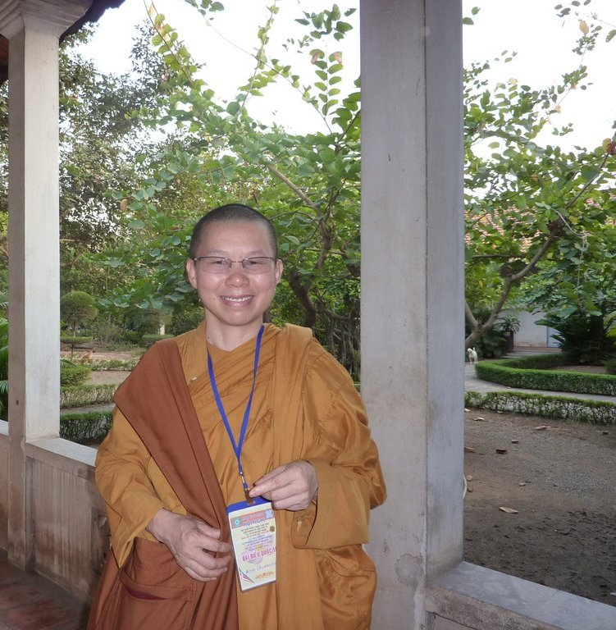[](http://santifm.org/santi/wp-content/uploads/2012/07/AyyaSudhamma-adjusted-imag.jpg)